This guide will walk through the configuration of several Node-RED flows to interact with the Meraki and WebEx Teams APIs. It will demonstrate how to think about connecting APIs and the Internet of Things by using flow-based programming. This concept is great for Network Engineers where you can think of routing packets through your application. You will be using your own Meraki Network and Cisco WebEx Teams accounts to interact with the APIs.

The labs should go quickly once the prerequisites and sample flows are installed. The following tools and sample applications will be helpful to you beyond this lab.

* Prerequisites
* Node-RED: Flow based programming tool
* Install
* 5 minute video
* Ngrok: Reverse proxy to expose your local application to the public Internet.
* Install
* Make ngrok available in path
* Resources
* Meraki Dashboard
* Cisco WebEx Teams Developer Portal
* Start Node-RED and Create a Tunnel

Before we begin working with the lab applications, we must first ensure Node-RED has been successfully installed and running. The link to install Node-RED is in the prerequisites. To run the application, open a command terminal and type “node-red”.

$ node-red

You can then access the Node-RED editor at http://localhost:1880.

Ngrok

To make your local Node-RED instance available to the public Internet, run ngrok in a new terminal window. This will create a dynamic tunnel which routes http (80/443) to Node-RED (1880).

$ ngrok http 1880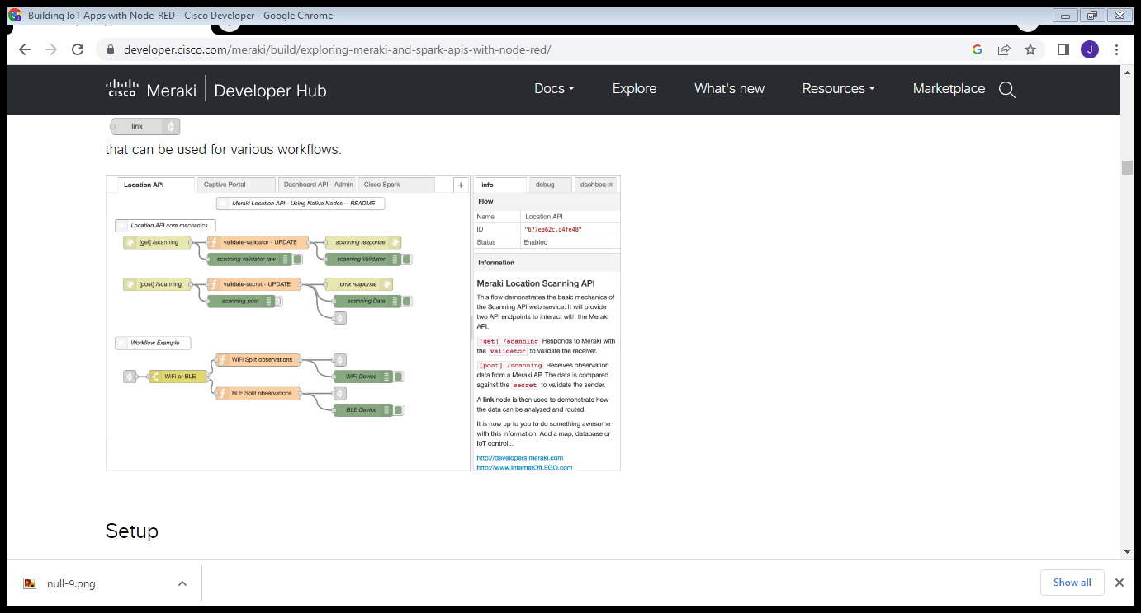

You now have an encrypted and unencrypted URL that you can use for your labs. In addition, ngrok will display all of the connection requests as they happen, which can be helpful when troubleshooting.

In this example, I would use https://535f455c.ngrok.io for my server location.You can easily test this by navigating to your URL in a browser. It will open Node-RED if working properly.

Install Lab Flows

Open the Flow’s library page and copy the flow JSON text at the bottom of the page into your clipboard.

Import the flow in Node-RED by pasting it into the Clipboard.

Deploy your changes.

You are now ready to begin the labs!

Scanning API

Meraki wireless networks have the ability to track WiFi and Bluetooth devices and relay this telemetry data via an API.

Receive Telemetry Data

This flow demonstrates the native functions of the Scanning API.

It then sends the observation data to a “link”nodethat can be used for various workflows.

Setup